Requirements and Execution Plan

February 7, 2011

# Egg Men Industries

*Cyle Lainson*

*Chad Ellsworth*

*Ryan Simmons*

# Table of Contents

|  |  |
| --- | --- |
| I Introduction | 1 |
| II Problem Statement | 1 |
| 1 Background and History | 1 |
| 2 Business Issues | 1 |
| 3 Production and Research | 2 |
| 4 Summary | 2 |
| III Solution Statement | 2 |
| 1 General Architecture | 3 |
| 2 Connections | 3 |
| IV Functional Requirements | 4 |
| 1 General Tasks | 4 |
| 2 Security | 4 |
| 3 Modeling | 5 |
| V Non-Functional Requirements | 5 |
| 1 Documentation | 5 |
| 2 Modular | 5 |
| VI Constraints and Feasibility Issues | 6 |
| 1 Constraints | 6 |
| 2 Feasibility Issues | 6 |
| VII Execution Plan | 6 |
| 1 Calendar | 7 |
| 2 Possible Changes | 8 |
| VIII References | 8 |

**I. Introduction**

SCREEN3 is a model used by the EPA for tracking airborne pollution from various sources over time1. It has been used for several years as the first program environmental engineers use to track pollution and determine if a source falls within legal limits. Unfortunately, the program isn’t very user friendly, and must be installed onto a computer before use. Our objective is to make a simple, online application that would allow engineers to make use of the SCREEN3 model from any computer connected to the internet, save their data for later retrieval, and receive the graphs and data they need to solve a problem.

**II. Problem Statement**

**1. Background and History**

SCREEN3 is an air quality model released by the United States Environmental Protection Agency, or EPA, for the purposes of predicting the concentration of pollution that will be produced from industrial smoke stacks and other sources, as well as how that pollution will disperse over time.1

The main use of this model is to predict the amount and spread of pollution from industrial buildings before they are created. By doing so companies can ensure that their system will conform to any environmental protection laws, such as the Clean Air Act of 19902. If the program falls close to the legal limit other, more thorough models are used to verify.

The original model is provided by the EPA for download on their website, along with all of the FORTRAN code used to create it1. However, this model is not compatible with a wide variety of operating systems or platforms. Several attempts have been made to commercialize this product, yet these versions are still not very user-friendly, and none of them truly utilize the Internet. In a nutshell, this model has not been incorporated into a piece of software that allows for quick and fool-proof access.

**2. Business Issues**

An easy-to-use, fully compatible piece of software which utilizes this model would greatly ease the burden of environmental engineers that use it today. Judging by the similar software on the market, it should not be difficult for a well-made SCREEN3 program to earn its place among the upper echelon of air quality modeling software. In addition, because the SCREEN3 model has seen widespread use over the past several years and is judged by the EPA to be highly accurate and reliable, it makes sense to incorporate it into a piece of software that has the potential to be adopted by a wide variety of users of various platforms. SCREEN3 programs which run on smart phones such as the iPhone are nonexistent, and such a product could be extremely helpful to professionals who are without their laptop and need to use an accurate model, perhaps in the field. Furthermore, offering users the option to store their results and view a large amount of air quality predictions online, which no other product does, would make for a standout product which would be coveted by engineering professionals.

**3. Production and Research**

As mentioned above, the EPA offers the SCREEN3 model freely on its website as a standalone program. It has been deemed over the past several years as extremely accurate. However it is not user-friendly, is prone to user error, and has many compatibility issues with operating systems. One company, Lakes Environmental, has stepped up and added a simple user interface that greatly increases the reliability of the program along with the ease of use. Their program, Screen View, allows users to install the system on their computer and use it with little difficulty, in addition to graphing the data for them3. We will be using this system as a stepping stone in how we develop our own online interface, while adding features that are only available by utilizing the internet. By not requiring users to download and install anything they will be able to access the model from any computer with internet access, including smart phones. The addition of being able to save their predictions onto the online server allows them to further access any information they have inputted from anywhere, giving them much more flexibility in their presentation of the results.

**4. Summary**

* SCREEN3 is an EPA air quality model used mainly to predict pollution levels.
* Though software which utilizes this model is widely available, none of them really stand out as being particularly user-friendly.
* No such software has integrated the Internet into their project to provide a more useful experience.
* Compatibility issues are very common among these types of products, and smart phone compatibility is nonexistent.
* Many freeware products exist, including the SCREEN3 model itself, which will provide a vast wealth of information to build upon.

SCREEN3 is a widely used pollution-tracking model which is nearly impossible to use in its original, open-source state. Some existing programs work to alleviate this problem; unfortunately none of these programs are user-friendly or portable. Our goal is to build on this past work to create a simple, web-based program which anyone can use over the internet.

**III. Solution Statement**

Our overall vision for this project is to create an entirely web-based system. The system will provide the user with all the tools necessary to implement the SCREEN3 model in a straightforward manner. In order to make the procedure even more convenient, the user will have the option to save their data from each entry. This saved data will then automatically re-enter all the relevant input fields for them, making small adjustments and re-graphing a simple endeavor.

In order to make the system secure, we intend to add a user name and password system. The password will only be given to those that have paid their subscription or have otherwise been given access by the administrator.

Finally, our hope is to make the system compatible with all major operating systems and internet browsers, including a number of smart phones, most prominently the iPhone. This will give our web based program much needed portability, and give a level of functionality not yet seen on the market.

**1. General Architecture**

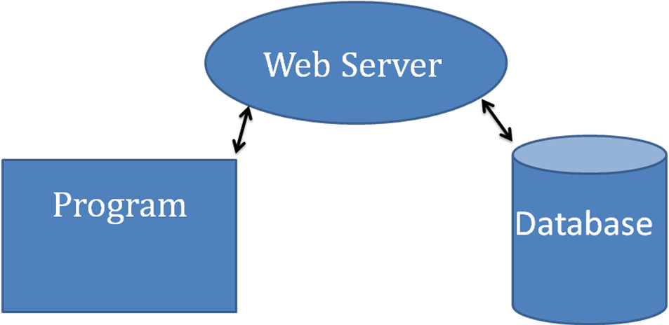

**2. Connections**

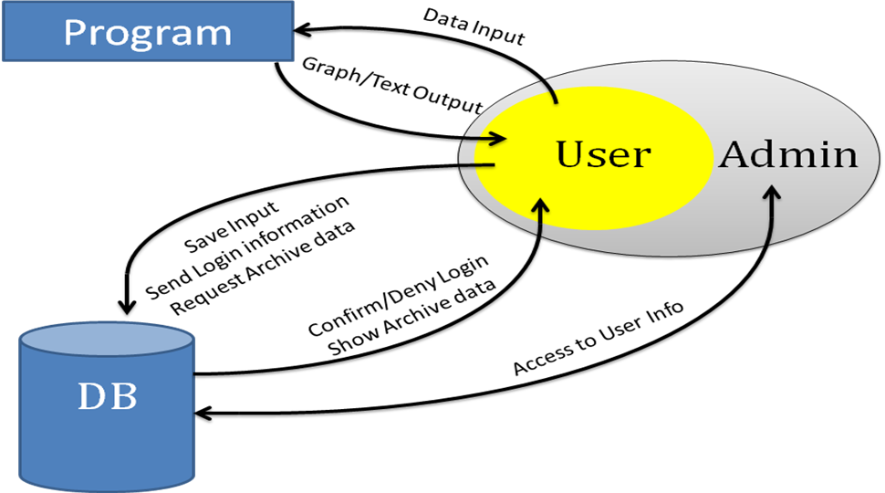

This system will consist of three main entities: the web server, the program, and the database.

The web server will be where the user accesses the system. This is where the user logs into the system, employs the SCREEN3 model, accesses previously archived data, increases their subscription, and changes their password. There is an additional administrator that holds all the abilities that the user has along with the ability to access all the user data with a limited ability to change it. They will have the power to extend subscriptions, change a user’s password, add or delete users, and also add or delete any archived data.

The program will be the web server’s access to the SCREEN3 model. It will send input data into the program which will then interface with SCREEN3 to generate the ASCII data. This data will then be used to create a graph and both the ASCII data and the graph will be sent back and displayed on the appropriate web page.

The database will hold all necessary data that needs to be saved for later use. This includes user names, passwords, archived input data, and subscription information. This is only accessible through the web server system.

**IV. Functional Requirements**

Functional requirements define the promised functionality of the system. They define the system's features – a broad description of what the system will do. Functional requirements do not address how the system will implement any particular feature.

**1. General Tasks:** Tasks which the system must perform effectively.

1.1. The program must be usable on the internet.

1.2. SCREEN3 must be able to be used to model input data.

1.3. Data must be able to be saved locally or on the server.

1.4. Users must be able to view data saved locally or on the server.

**2. Security:** Covers authentication and user/data management.

2.1. Authentication

2.1.1. Authentication Password

2.1.1.1. Potential user must send a username and email.

2.1.1.2. In return, they receive an authentication password.

2.1.1.3. Password can then be used to login to the website and access the service.

2.1.2. Users must log in to the system before they are able to use it.

2.1.2.1. A log in is performed by entering a valid username and password.

2.1.2.2. Users are able to log out of the system.

2.2. User Management

2.2.1. Administrator(s) can add user accounts to the system.

2.2.1.1. The system provides a procedure for administrator(s) to add user accounts.

2.2.2. Administrator(s) can remove accounts from the system.

2.2.2.1. The system provides a procedure for administrator(s) to remove user accounts.

2.2.3. Administrator(s) can view accounts on the system.

2.2.3.1. The system provides a procedure for administrator(s) to view user accounts.

2.2.4. Administrator(s) can remove inputted data from accounts on the system.

2.2.4.1. The system provides a procedure for administrator(s) to remove inputted data from accounts.

**3. Modeling:** Covers specific EPA models for use on the system

3.1. Ability to add new models

3.2. SCREEN3 needs to be incorporated into the system.

3.2.1. User can enter necessary data for SCREEN3 model.

3.2.1.1. This includes optional data relevant to SCREEN3.

3.2.2. Data is then input to the server

3.2.3. Server displays computed graph and popular ASCII format data.

3.2.3.1. ASCII format must match a specific format given by other systems.

3.2.4. User is given the option to save the graph and ASCII format data onto their local system.

3.2.5. User is given the option to save the input data to the server.

3.2.6. User can access previous input data that has been saved to the server.

**V. Non-Functional Requirements**

A non-functional requirement is a specification that does not directly relate to the functionality of the project.

**1. Documentation**

1.2. System-Level Documentation

1.2.1. We document the entire project as a whole and explain what each individual piece does in broad terms.

1.3. Code-Level Documentation

1.3.1. All code is fully documented. This includes comment blocks and method citations.

**2. Modular**

2.1 The system needs to be able to easily add new environmental models for selection by the user.

**VI. Constraints and Feasibility Issues**

**1. Constraints**

1.1. Cross-Platform User Interface

1.1.1. The online interface should be accessible from major platforms.

1.1.1.1. iPhone Operating System (iOS), OS X, Windows (XP, Vista, Windows 7), and Linux

1.1.2. The remote interface should be accessible from major browsers.

1.1.2.1. Google Chrome, Internet Explorer, Firefox, Safari, and Opera

**2. Feasibility Issues**

* We will require some sort of server space to hold our two databases. This server space may need to be somewhat sizable if we are to allow users to store their data on the server for future reference.
* We have limited experience generating web pages. We have each taken a semester course at NAU but this website will be considerably more complicated than any website we have previously created. However, we are confident that any problems that arise will be able to be worked through with the help of online tutorials and the like.
* We are not environmental engineers and have no experience measuring air quality. With our implementation plan, this should only impact our testing of the system. Since we are reusing the SCREEN3 model we will not need to recreate any of the formulas. Instead we will simply input data into the model and get a result. The problem with testing is that we do not know what valid inputs into the system look like, nor do we know what valid outputs should be. To make up for this lack of experience we will use the examples that come with the Lakes Environmental Screen View program for initial testing, then we will continue with testing using real world models.

# VII. Execution Plan

In the short term, the first thing we would like to get done is the web site. By February 8th we hope to have the basic structure of the website done. This means that the basic flow of the site will be finished, but with little to no functionality. Next, by February 15th we will have all of the forms set up on the website, and a week later, by the 22nd, we hope they will be completely functional and in sync with the database. This two-week window will give us ample time to ensure that the forms are laid out properly and look as professional as possible, as well as function correctly. With all of the forms in place, we will spend the next week putting the finishing touches on the design and overall look of the site using CSS. By March 1st, we should have the website completely finished.

After the site is finished, the next step is to tackle SCREEN3 functionality. The data modeling program will first be developed separately from the website, and then incorporated in once it is running smoothly. Since the SCREEN3 model already exists in a scientifically correct form, most of the work surrounding the program will focus on ensuring the model’s FORTRAN code will be integrated into the Java program successfully, as well as generating graphs based on the SCREEN3 output. We hope to have the modeling program fully functional by March 15th, and then incorporated into the website by March 28th. Then, we will use the rest of our available time to thoroughly test our system.

**1. Calendar**

|  |  |  |  |  |  |  |
| --- | --- | --- | --- | --- | --- | --- |
| **FEBRUARY** | | | | | | |
| **Sunday** | **Monday** | **Tuesday** | **Wednesday** | **Thursday** | **Friday** | **Saturday** |
|  |  | 1 | 2 | 3 | 4 | 5 |
| 6 | 7 | 8  Website Layout Complete | 9 | 10 | 11 | 12 |
| 13 | 14 | 15  Forms Placed | 16 | 17 | 18 | 19 |
| 20 | 21 | 22  Forms Functional | 23 | 24 | 25 | 26 |
| 27 | 28 |  |  |  |  |  |

|  |  |  |  |  |  |  |
| --- | --- | --- | --- | --- | --- | --- |
| **MARCH** | | | | | | |
| **Sunday** | **Monday** | **Tuesday** | **Wednesday** | **Thursday** | **Friday** | **Saturday** |
|  |  | 1  Website Complete | 2 | 3 | 4 | 5 |
| 6 | 7 | 8 | 9 | 10 | 11 | 12 |
| 13 | 14 | 15  Modeling Program Functional | 16 | 17 | 18 | 19 |
| 20 | 21 | 22 | 23 | 24 | 25 | 26 |
| 27 | 28 | 29  Modeling Program Works With Website | 30 | 31 |  |  |

|  |  |  |  |  |  |  |
| --- | --- | --- | --- | --- | --- | --- |
| **APRIL** | | | | | | |
| **Sunday** | **Monday** | **Tuesday** | **Wednesday** | **Thursday** | **Friday** | **Saturday** |
|  |  |  |  |  | 1 | 2 |
| 3 | 4 | 5  Deadline: Must Be Finished | 6 | 7 | 8 | 9 |

**2. Possible Changes**

If there is any specific milestone which will probably take longer than the time allotted here, it would probably be either the form functionality or the modeling program functionality. If we do need more time to work on either of these sections, we have left ourselves an additional week before the point in time when we would like to have the entire project ready for testing, April 5th. If this is still not enough time, we can certainly lessen the amount of time we have set aside to incorporate the modeling program into the website. It probably will not require two weeks of work to get a fully functional Java program to work with a fully functional website. That being said, we still hope to meet each milestone promptly and have plenty of time to ensure the program and website is working well together.

# VIII. References

1: http://www.epa.gov/scram001/dispersion_screening.htm

2: http://www.epa.gov/air/caa/

3: http://www.weblakes.com/products/screen/index.html